- Construct a detailed concept map showing the relationship between CPU (ALU, Control Unit, Registers), memory (cache, RAM), and I/O devices. Extend the map to include single-bus, multi-bus, and hierarchical bus structures, and clearly illustrate how data and control signals flow among these components during execution. Indicate possible points of delay or bottlenecks and how different bus structures help in improving performance.
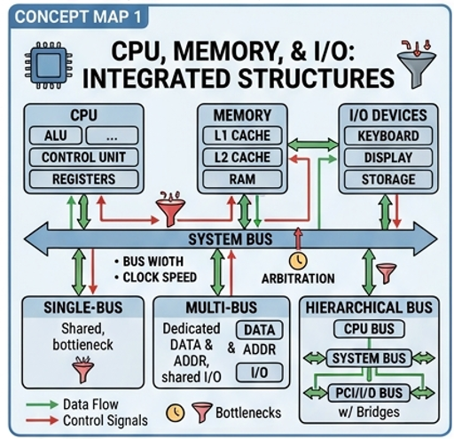

- Develop a comprehensive concept map linking the instruction execution cycle (fetch, decode, execute) with CPU performance parameters such as CPI, clock cycles, and execution time. Show how each stage contributes to overall execution time, and include connections to factors like memory access, instruction complexity, and pipeline stalls. Also, represent how benchmarking is used to evaluate performance.
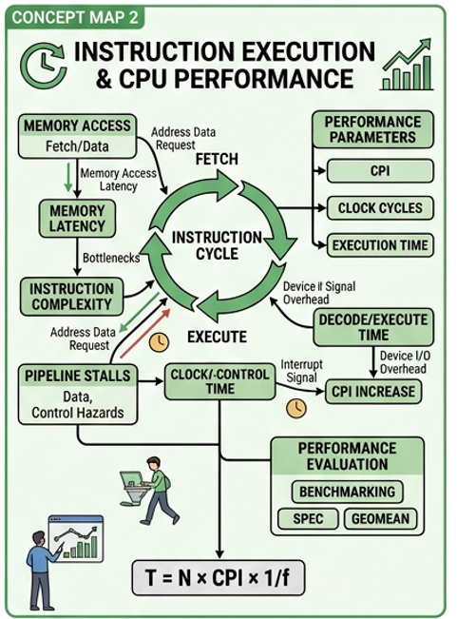

- Create a concept map comparing 8085 and 8086 architectures, including their instruction sets, register organization, addressing modes, and memory segmentation (in 8086). Clearly show how these architectural features influence program execution, multitasking capability, and efficiency in real-time applications.
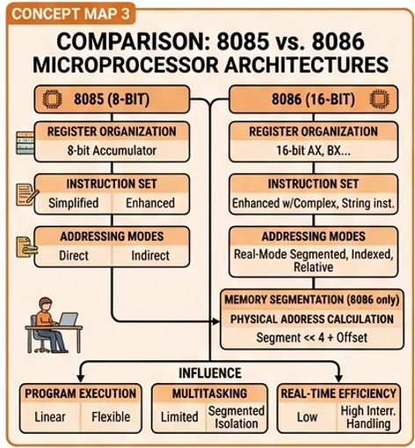

- Draw a detailed concept map that connects various addressing modes (immediate, direct, register, indirect, indexed) with instruction types (data transfer, arithmetic, control instructions). Illustrate how each addressing mode affects memory access time, instruction size, and execution speed, and show real-world scenarios where specific addressing modes are preferred.
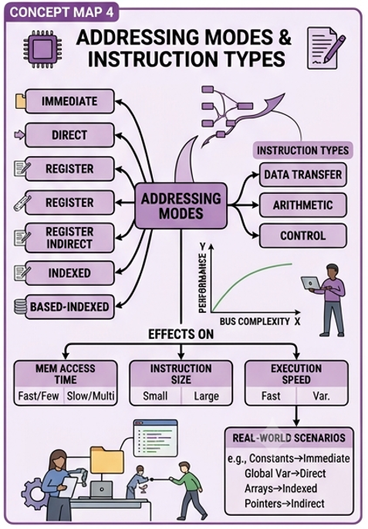

- Prepare an elaborate concept map integrating number systems (binary and hexadecimal) with instruction representation, memory storage, and debugging processes. Show how data is converted between formats, how instructions are stored and interpreted by the CPU, and why hexadecimal representation is commonly used in low-level programming and system design.
